Qwar

Specification Documentation

**Team Name : Thinker**

**Team Members : Indra Winata**

**Jeffrey**

**Martono**

**Thomas Rico**

**12/8/2014**

1. Background Story 1

1.1 Background Story 1

1.1.1 Overview of Game 1

1.1.2 Background Story 1

2. Game Play Look and Feel 1

2.1 Appearance 1

2.2 Players Roles and Actions 3

2.3 Development Specifications 4

3. SUMMARY 5

# Background Story

## Background Story

### Overview of Game

The name of the game is QWar. QWar is a game that provides questions about many kind of knowledge, such as general knowledge, history, science, etc. This knowledge category can be added later or can be added for specific used. The genre of this game is a multiplayer action game.

### Background Story

QWar, an animated multiplayer quiz game, is made to increase the learning willingness of people in the world. This game can invite people to play while learning, because the current average world people likes to play games.

# Game Play Look and Feel

## Appearance

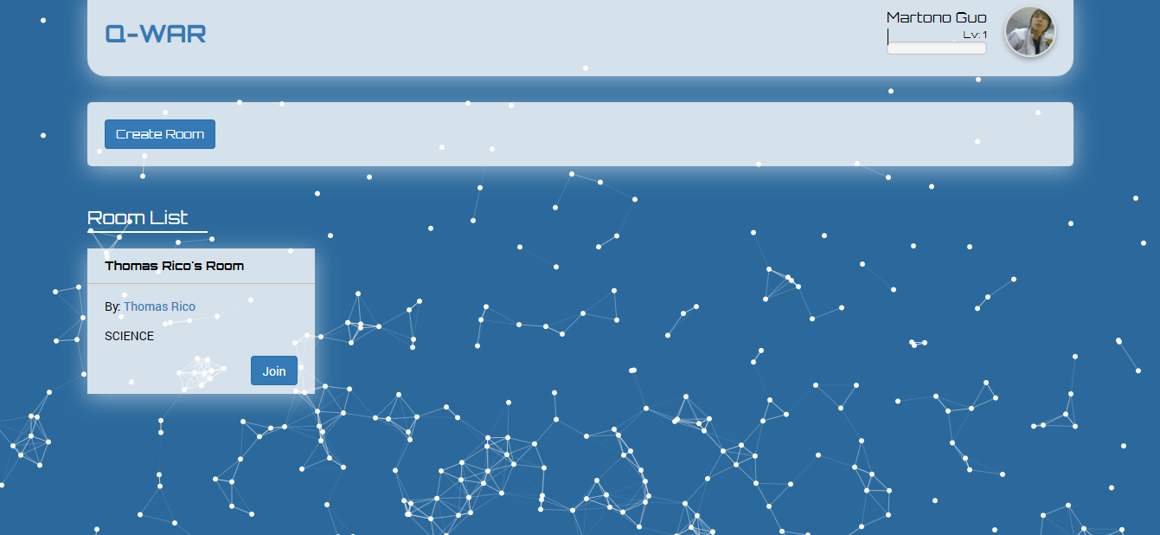

Figure 1. Qwar – Room List Screen

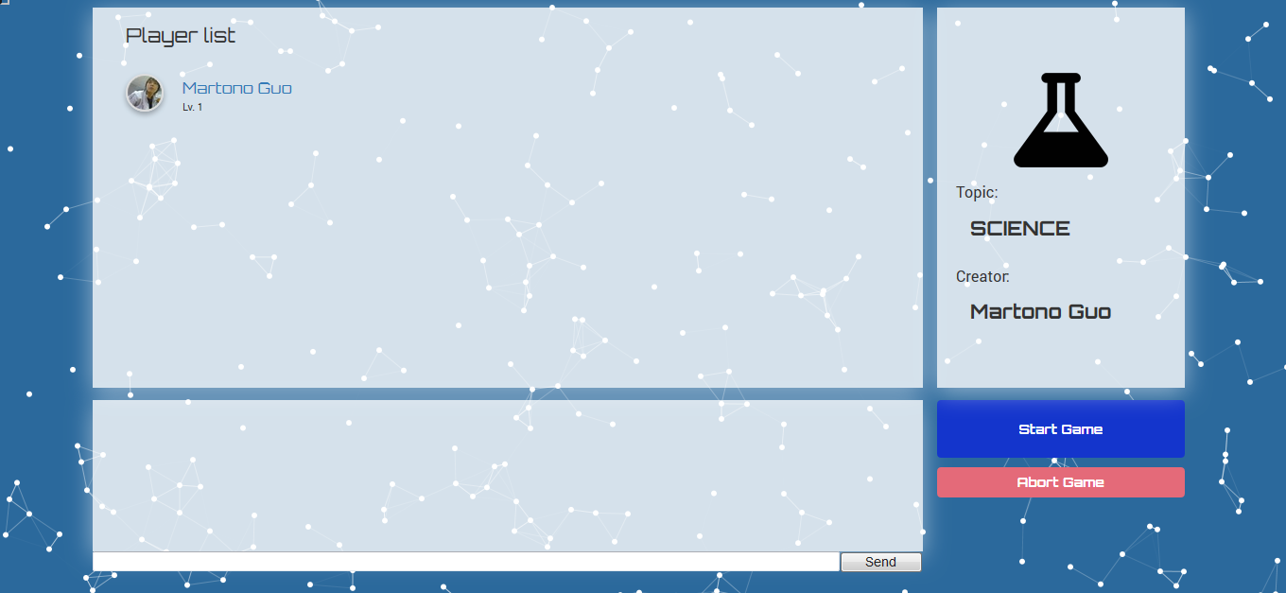

Figure 2. Qwar – Room Game Screen

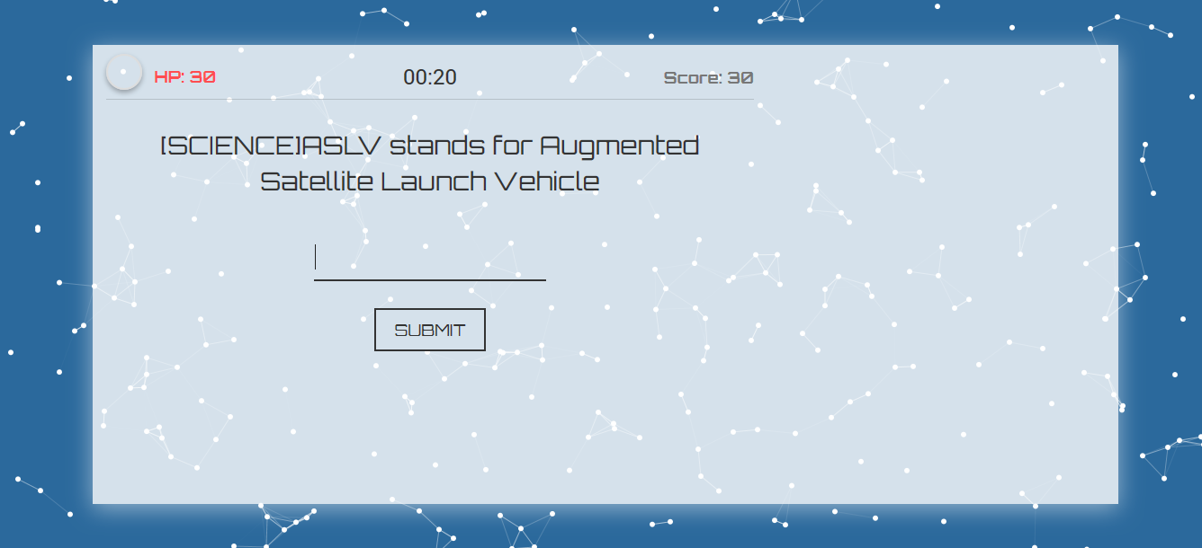

Figure 3. Qwar – Room Game Screen

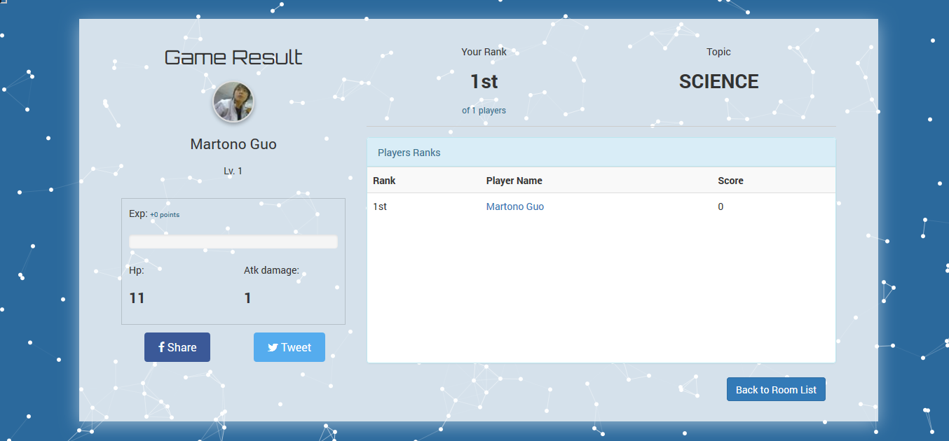

Figure 4. Qwar – Game Result Screen

The sample screen above illustrates the look of QWar. You will act as an answerer. This game is a great game to answer questions quickly and precisely in order to get the highest score and add experience to improve your level.

## Players Roles and Actions

* **User/Players**

1. Publicly open to register, using Twitter and Facebook API
2. Login (using Facebook API 🡪 proxified using API Tools, or using Twitter API)
3. Profile page (profile picture, quiz history, level, experience, HP, Attack Point)
4. Choose Available Quiz/Topic and create room based on it. Or Join Available Room
5. As host, user can start the game / room
6. While waiting the game to be started, players can chat using the chat box in the waiting room
7. Players can share their quiz history on Facebook or Twitter

* **Game**

1. Each player have HP and Attack Point
2. When game start, each player have to answer the question displayed on the screen just by typing the answer and press enter to submit. They can try as many as they can until one of the player get the correct answer or the time to answer that is over. The question is same among other players to maintain a fair game
3. When the time to answer is over and no one get the correct answer, each player’s HP will be decreased.
4. When there is 1 person who get the correct answer, all players will be counted as lose (at that question) and there will be a popup window.
   1. For player with correct answer: player will attack, and
   2. For other players: they will be attacked and lose their HP.
5. Player with 0 HP can be considered as dead and will remain in the room but could not answer any questions.
6. The game/quiz will end if
   1. There is only 1 person who is alive
   2. Quiz time reached
7. When the game ends, it will display a list of players with highest Score first to lowest.
8. The questions are randomly taken from database.

* **Quiz**

1. Have difficulty level. Can be filtered in user search.
2. Each Quiz has maximum game time (i.e 10 minute)
3. Each Quiz consist of several questions
4. Each question have an experience point to be given to the player who answer it correctly
5. Each question have time limit to be answered
6. Answer is an essay, players just have to type the answer correctly, not case sensitive.

## Development Specifications

* **Technology**

1. HTML5 animation : used in background of the application
2. PHP : used as back-end process
3. NodeJS : used as back-end process to connect multiple players in the same game and for chat system
4. MySQL : store the player stats, history, questions, etc
5. HTML/HTML5, CSS, bootstrap, Javascript, etc will be used as front-end/UI development

* **API Usage**

1. APITools 🡪 Facebook API

**3. Summary**

Teach players about everything mentioned in tailored Quiz. Schools or companies can use this application to measure the knowledge of their students or employees. They even can use this application to measure the knowledge of public people about their products, services, etc.

For further development, we want to build admin module to be given to schools and companies so they can add their own quiz and set quiz to public or invitation only. Each admin can create other admin account with certain access permissions.

For further development in the schools, this game can be used to test the ability of their students and the schools’ admission test. The school can also use this application to provide scholarships with a value chosen from the implementation of the quiz.

For further development of the companies, this game can be used to test the ability of their employees and also admission test companies, such as psychological test and capabilities test in specific areas. The company can use this quiz to improve the performance of every employee. This game can also be used for questionnaires such as the assessment of a product to general public / people.

We also will create category/folder for the quiz so players can find the related quiz easily in further development, as well as the title. Items to increase the stats or change the attack animation and more skills can also be developed later.